федеральное государственное автономное образовательное учреждение высшего образования
«НАЦИОНАЛЬНЫЙ ИССЛЕДОВАТЕЛЬСКИЙ УНИВЕРСИТЕТ ИТМО»

ОТЧЕТ
по лабораторной работе №3
«Создание коммутируемой сети Ethernet»
по дисциплине «Администрирование систем и сетей»
Вариант на оценку 5

Авторы: Кулаков Н. В.
Факультет: ПИиКТ
Группа: P34312
Преподаватель: Афанасьев Д.Б.


Санкт-Петербург 2023
Оглавление
1. Лабораторная работа 1. Основы Ethernet и конфигурирование VLAN 3
1.1. Задачи 3
1.2. Топология сети 3
1.3. Настраивание и диагностические команды 3
1.4. Конфигурации 9
2. Лабораторная работа 2. Протокол связующего дерева (STP) 13
2.1. Задачи 13
2.2. Топология сети 13
2.3. Настраивание и диагностические команды 13
2.4. Конфигурации 21
3. Лабораторная работа 3. Агрегирование каналов Ethernet 22
3.1. Задачи 22
3.2. Топология сети 23
3.3. Настраивание и диагностические команды 23
3.4. Конфигурации 23
4. Лабораторная работа 4. Связь между VLAN 23
4.1. Задачи 23
4.2. Топология сети 23
4.3. Настраивание и диагностические команды 23
4.4. Конфигурации 23

Лабораторная работа 1. Основы Ethernet и конфигурирование VLAN

Задачи
- Создание VLAN.
- Конфигурирование VLAN на основе портов.
- Конфигурирование VLAN на основе MAC-адресов.

Топология сети
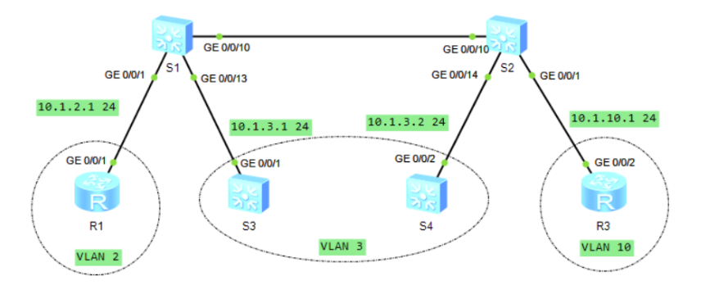

Настраивание и диагностические команды
Шаг 1.
Отключили порты на S1. Работающие порты на S1:
Interface PHY Protocol InUti OutUti inErrors outErrors
GigabitEthernet0/0/1 up up 0% 0% 0 0
GigabitEthernet0/0/2 down down 0% 0% 0 0
GigabitEthernet0/0/3 down down 0% 0% 0 0
GigabitEthernet0/0/4 down down 0% 0% 0 0
GigabitEthernet0/0/5 down down 0% 0% 0 0
GigabitEthernet0/0/6 down down 0% 0% 0 0
GigabitEthernet0/0/7 down down 0% 0% 0 0
GigabitEthernet0/0/8 down down 0% 0% 0 0
GigabitEthernet0/0/9 down down 0% 0% 0 0
GigabitEthernet0/0/10 up up 0% 0% 0 0
GigabitEthernet0/0/11 *down down 0% 0% 0 0
GigabitEthernet0/0/12 *down down 0% 0% 0 0
GigabitEthernet0/0/13 up up 0% 0% 0 0
Тоже самое на S2:
Interface PHY Protocol InUti OutUti inErrors outErrors
GigabitEthernet0/0/1 up up 0% 0% 0 0
GigabitEthernet0/0/2 down down 0% 0% 0 0
GigabitEthernet0/0/3 down down 0% 0% 0 0
GigabitEthernet0/0/4 down down 0% 0% 0 0
GigabitEthernet0/0/5 down down 0% 0% 0 0
GigabitEthernet0/0/6 down down 0% 0% 0 0
GigabitEthernet0/0/7 down down 0% 0% 0 0
GigabitEthernet0/0/8 down down 0% 0% 0 0
GigabitEthernet0/0/9 down down 0% 0% 0 0
GigabitEthernet0/0/10 up up 0% 0% 0 0
GigabitEthernet0/0/11 *down down 0% 0% 0 0
GigabitEthernet0/0/12 *down down 0% 0% 0 0
GigabitEthernet0/0/13 down down 0% 0% 0 0
GigabitEthernet0/0/14 up up 0% 0% 0 0

Шаг 2.
Вариант 1 настройки (через undo portswitch и задание ip адресов) не работает, так как коммутатор не поддерживает. Поэтому при настройке использовал сценарий 2 с VlanIf.
[S3-GigabitEthernet0/0/1]dis this
#
interface GigabitEthernet0/0/1
port link-type access
port default vlan 3
#
return
[S3-Vlanif3]dis this
#
interface Vlanif3
ip address 10.1.3.1 255.255.255.0
#
return
Аналогично и на S4.
Шаг 3.
Создаем vlan 2,3,10 на S1, S2:
[S1]dis this
#
sysname S1
#
vlan batch 2 to 3 10
#
[S2]dis this
#
sysname S2
#
vlan batch 2 to 3 10
#
Шаг 4.
Настроим сеть Vlan на основе портов. S1-G0/0/1 — access vlan 2. S1-G0/0/13, S2-G0/0/14 — access vlan 3. S1-G0/0/10, S2-G0/0/10 — магистральные (trunk), пропускающие vlan 2,3, запрещаем vlan 1.
# S1:
interface GigabitEthernet0/0/1
port link-type access
port default vlan 2
#
#
interface GigabitEthernet0/0/13
port link-type access
port default vlan 3
#
return
#
interface GigabitEthernet0/0/10
port link-type trunk
undo port trunk allow-pass vlan 1
port trunk allow-pass vlan 2 to 3
#
return
Аналогично и на S3.
Шаг 5.
Сконфигурируем vlan 10 с фильтром на основе mac-адресов.
[S2-GigabitEthernet0/0/1]dis this
#
interface GigabitEthernet0/0/1
port hybrid untagged vlan 10
mac-vlan enable
#
return
Чтобы получить MAC-адрес:
[R3]dis arp
IP ADDRESS MAC ADDRESS EXPIRE(M) TYPE INTERFACE VPN-INSTANCE
VLAN/CEVLAN PVC
------------------------------------------------------------------------------
10.1.10.1 00e0-fc00-23d2 I - GE0/0/2
------------------------------------------------------------------------------
Total:1 Dynamic:0 Static:0 Interface:1
В результате:
[S2]dis mac-vlan ?
mac-address MAC address
vlan Virtual LAN

[S2]dis mac-vlan vlan 10
---------------------------------------------------
MAC Address MASK VLAN Priority
---------------------------------------------------
00e0-fc00-23d2 ffff-ffff-ffff 10 0

Total MAC VLAN address count: 1
Также разрешаем vlan 10 на интерфейсах, на которых настроен hybrid vlan.
[S1-GigabitEthernet0/0/1]dis vlan
The total number of vlans is : 4
--------------------------------------------------------------------------------
U: Up; D: Down; TG: Tagged; UT: Untagged;
MP: Vlan-mapping; ST: Vlan-stacking;
#: ProtocolTransparent-vlan; *: Management-vlan;
--------------------------------------------------------------------------------

VID Type Ports
--------------------------------------------------------------------------------
1 common UT:GE0/0/2(D) GE0/0/3(D) GE0/0/4(D) GE0/0/5(D)
GE0/0/6(D) GE0/0/7(D) GE0/0/8(D) GE0/0/9(D)
GE0/0/11(D) GE0/0/12(D) GE0/0/14(D) GE0/0/15(D)
GE0/0/16(D) GE0/0/17(D) GE0/0/18(D) GE0/0/19(D)
GE0/0/20(D) GE0/0/21(D) GE0/0/22(D) GE0/0/23(D)
GE0/0/24(D)

2 common UT:GE0/0/1(U)
TG:GE0/0/10(U)
3 common UT:GE0/0/13(U)
TG:GE0/0/10(U)

10 common TG:GE0/0/10(U)

VID Status Property MAC-LRN Statistics Description
--------------------------------------------------------------------------------

1 enable default enable disable VLAN 0001
2 enable default enable disable VLAN 0002
3 enable default enable disable VLAN 0003
10 enable default enable disable VLAN 0010
[S2]dis vlan
The total number of vlans is : 4
--------------------------------------------------------------------------------
U: Up; D: Down; TG: Tagged; UT: Untagged;
MP: Vlan-mapping; ST: Vlan-stacking;
#: ProtocolTransparent-vlan; *: Management-vlan;
--------------------------------------------------------------------------------

VID Type Ports
--------------------------------------------------------------------------------
1 common UT:GE0/0/1(U) GE0/0/2(D) GE0/0/3(D) GE0/0/4(D)
GE0/0/5(D) GE0/0/6(D) GE0/0/7(D) GE0/0/8(D)
GE0/0/9(D) GE0/0/11(D) GE0/0/12(D) GE0/0/13(D)
GE0/0/15(D) GE0/0/16(D) GE0/0/17(D) GE0/0/18(D)
GE0/0/19(D) GE0/0/20(D) GE0/0/21(D) GE0/0/22(D)
GE0/0/23(D) GE0/0/24(D)

2 common TG:GE0/0/10(U)
3 common UT:GE0/0/14(U)
TG:GE0/0/10(U)

10 common UT:GE0/0/1(U) GE0/0/2(D) GE0/0/3(D)
TG:GE0/0/10(U)

VID Status Property MAC-LRN Statistics Description
--------------------------------------------------------------------------------
1 enable default enable disable VLAN 0001
2 enable default enable disable VLAN 0002
3 enable default enable disable VLAN 0003
10 enable default enable disable VLAN 0010
Проверка:
[R1-GigabitEthernet0/0/1]ping 10.1.10.1
PING 10.1.10.1: 56 data bytes, press CTRL_C to break
Request time out
Request time out
Request time out

--- 10.1.10.1 ping statistics ---
3 packet(s) transmitted
0 packet(s) received
100.00% packet loss
[S3-Vlanif3]ping 10.1.3.2
PING 10.1.3.2: 56 data bytes, press CTRL_C to break
Reply from 10.1.3.2: bytes=56 Sequence=1 ttl=255 time=140 ms
Reply from 10.1.3.2: bytes=56 Sequence=2 ttl=255 time=90 ms
Reply from 10.1.3.2: bytes=56 Sequence=3 ttl=255 time=80 ms
Reply from 10.1.3.2: bytes=56 Sequence=4 ttl=255 time=90 ms
Reply from 10.1.3.2: bytes=56 Sequence=5 ttl=255 time=60 ms
[S1]dis mac-address verbose
MAC address table of slot 0:
-------------------------------------------------------------------------------
MAC Address VLAN/ PEVLAN CEVLAN Port Type LSP/LSR-ID
VSI/SI MAC-Tunnel
-------------------------------------------------------------------------------
4c1f-ccb2-219b 3 - - GE0/0/10 dynamic 0/-
4c1f-cc2b-087c 3 - - GE0/0/13 dynamic 0/-
00e0-fc00-23d2 10 - - GE0/0/10 dynamic 0/-
-------------------------------------------------------------------------------
[S2]dis mac-address verbose
MAC address table of slot 0:
-------------------------------------------------------------------------------
MAC Address VLAN/ PEVLAN CEVLAN Port Type LSP/LSR-ID
VSI/SI MAC-Tunnel
-------------------------------------------------------------------------------
4c1f-cc2b-087c 3 - - GE0/0/10 dynamic 0/-
4c1f-ccb2-219b 3 - - GE0/0/14 dynamic 0/-
00e0-fc00-23d2 10 - - GE0/0/1 dynamic 0/-
-------------------------------------------------------------------------------
Total matching items on slot 0 displayed = 3

Конфигурации
R1:
#
interface GigabitEthernet0/0/0
#
interface GigabitEthernet0/0/1
ip address 10.1.2.1 255.255.255.0
#
interface GigabitEthernet0/0/2
#
interface NULL0
#
user-interface con 0
authentication-mode password
idle-timeout 0 0
S1:
#
sysname S1
#
vlan batch 2 to 3 10
#
interface Vlanif1
#
interface GigabitEthernet0/0/1
port link-type access
port default vlan 2
#
interface GigabitEthernet0/0/2
#
interface GigabitEthernet0/0/9
#
interface GigabitEthernet0/0/10
port link-type trunk
undo port trunk allow-pass vlan 1
port trunk allow-pass vlan 2 to 3 10
#
interface GigabitEthernet0/0/11
shutdown
#
interface GigabitEthernet0/0/12
shutdown
#
interface GigabitEthernet0/0/13
port link-type access
port default vlan 3
#
user-interface con 0
idle-timeout 0 0
#
S2:
#
sysname S2
#
vlan batch 2 to 3 10
#
vlan 10
mac-vlan mac-address 00e0-fc00-23d2 priority 0
#
interface Vlanif1
#
interface GigabitEthernet0/0/1
port hybrid untagged vlan 10
mac-vlan enable
#
interface GigabitEthernet0/0/2
port hybrid untagged vlan 10
mac-vlan enable
#
interface GigabitEthernet0/0/3
port hybrid untagged vlan 10
mac-vlan enable
#
interface GigabitEthernet0/0/10
port link-type trunk
undo port trunk allow-pass vlan 1
port trunk allow-pass vlan 2 to 3 10
#
interface GigabitEthernet0/0/11
shutdown
#
interface GigabitEthernet0/0/12
shutdown
#
interface GigabitEthernet0/0/13
#
interface GigabitEthernet0/0/14
port link-type access
port default vlan 3
#
#
user-interface con 0
idle-timeout 0 0
#
return
S3:
#
sysname S3
#
vlan batch 3
#
interface Vlanif1
#
interface Vlanif3
ip address 10.1.3.1 255.255.255.0
#
interface GigabitEthernet0/0/1
port link-type access
port default vlan 3
#
user-interface con 0
idle-timeout 0 0
#
return
S4:
#
sysname S4
#
vlan batch 3
#
interface Vlanif1
#
interface Vlanif3
ip address 10.1.3.2 255.255.255.0
#
interface GigabitEthernet0/0/1
#
interface GigabitEthernet0/0/2
port link-type access
port default vlan 3
#
user-interface con 0
idle-timeout 0 0
#
return
R3:
#
interface GigabitEthernet0/0/0
#
interface GigabitEthernet0/0/1
#
interface GigabitEthernet0/0/2
ip address 10.1.10.1 255.255.255.0
#
interface NULL0
#
user-interface con 0
idle-timeout 0 0
#
return

Лабораторная работа 2. Протокол связующего дерева (STP)

Задачи
- Включение STP.
- Изменение приоритетов мостов, чтобы контролировать выбор корневого моста.
- Изменение параметров порта, чтобы определить роль порта.
- Изменение протокола на протокол RSTP.
- Настройка граничных портов

Топология сети
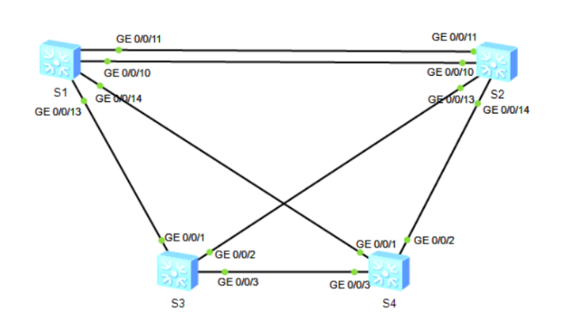

Настраивание и диагностические команды
Шаг 1.
Выполнить отключение G0/0/12 для S1 и S2.
[S1]int g0/0/12
[S1-GigabitEthernet0/0/12]shutdown
Шаг 2.
Включить STP. Статус связующего дерева:
#
sysname S1
#
stp mode stp
#
-------[CIST Global Info][Mode STP]-------
CIST Bridge :32768.4c1f-cca2-14ca
Config Times :Hello 2s MaxAge 20s FwDly 15s MaxHop 20
Active Times :Hello 2s MaxAge 20s FwDly 15s MaxHop 20
CIST Root/ERPC :32768.4c1f-cc30-36f6 / 20000
CIST RegRoot/IRPC :32768.4c1f-cca2-14ca / 0 # CIST regional root (mstp)
CIST RootPortId :128.10
BPDU-Protection :Disabled
TC or TCN received :242
TC count per hello :0
STP Converge Mode :Normal
Time since last TC :0 days 0h:5m:43s
Number of TC :11
Last TC occurred :GigabitEthernet0/0/10
----[Port10(GigabitEthernet0/0/10)][FORWARDING]----
Port Protocol :Enabled
Port Role :Root Port
Port Priority :128
Port Cost(Dot1T ) :Config=auto / Active=20000
Designated Bridge/Port :32768.4c1f-cc30-36f6 / 128.10
Port Edged :Config=default / Active=disabled
Point-to-point :Config=auto / Active=true
Transit Limit :147 packets/hello-time
Protection Type :None
Port STP Mode :STP
Port Protocol Type :Config=auto / Active=dot1s
BPDU Encapsulation :Config=stp / Active=stp
PortTimes :Hello 2s MaxAge 20s FwDly 15s RemHop 0
TC or TCN send :4
TC or TCN received :56
BPDU Sent :7
TCN: 4, Config: 3, RST: 0, MST: 0
BPDU Received :410
TCN: 0, Config: 410, RST: 0, MST: 0
[S1]dis stp brief
MSTID Port Role STP State Protection
0 GigabitEthernet0/0/10 ROOT FORWARDING NONE
0 GigabitEthernet0/0/11 ALTE DISCARDING NONE
0 GigabitEthernet0/0/13 ALTE DISCARDING NONE
0 GigabitEthernet0/0/14 ALTE DISCARDING NONE
[S2]dis stp brief
MSTID Port Role STP State Protection
0 GigabitEthernet0/0/10 DESI FORWARDING NONE
0 GigabitEthernet0/0/11 DESI FORWARDING NONE
0 GigabitEthernet0/0/13 DESI FORWARDING NONE
0 GigabitEthernet0/0/14 DESI FORWARDING NONE
[S3]dis stp brief
MSTID Port Role STP State Protection
0 GigabitEthernet0/0/1 DESI FORWARDING NONE
0 GigabitEthernet0/0/2 ROOT FORWARDING NONE
0 GigabitEthernet0/0/3 ALTE DISCARDING NONE
[S4]dis stp brief
MSTID Port Role STP State Protection
0 GigabitEthernet0/0/1 DESI FORWARDING NONE
0 GigabitEthernet0/0/2 ROOT FORWARDING NONE
0 GigabitEthernet0/0/3 DESI FORWARDING NONE
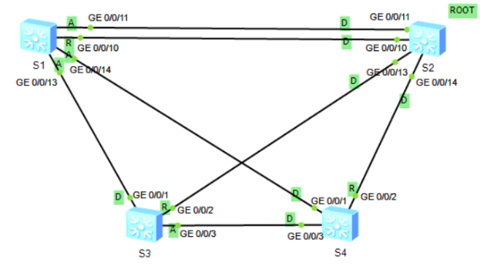
Шаг 3.
Сделать S1 — primary, S2 — secondary.
-------[CIST Global Info][Mode STP]-------
CIST Bridge :0 .4c1f-cca2-14ca # выставился в 0
Config Times :Hello 2s MaxAge 20s FwDly 15s MaxHop 20
Active Times :Hello 2s MaxAge 20s FwDly 15s MaxHop 20
CIST Root/ERPC :0 .4c1f-cca2-14ca / 0
CIST RegRoot/IRPC :0 .4c1f-cca2-14ca / 0
CIST RootPortId :0.0
BPDU-Protection :Disabled
CIST Root Type :Primary root
TC or TCN received :328
TC count per hello :0
STP Converge Mode :Normal
Time since last TC :0 days 0h:0m:11s
Number of TC :15
Last TC occurred :GigabitEthernet0/0/14
[S1]dis stp brief
MSTID Port Role STP State Protection
0 GigabitEthernet0/0/10 DESI FORWARDING NONE
0 GigabitEthernet0/0/11 DESI FORWARDING NONE
0 GigabitEthernet0/0/13 DESI FORWARDING NONE
0 GigabitEthernet0/0/14 DESI FORWARDING NONE
[S2]dis stp brief
MSTID Port Role STP State Protection
0 GigabitEthernet0/0/10 ROOT FORWARDING NONE
0 GigabitEthernet0/0/11 ALTE DISCARDING NONE
0 GigabitEthernet0/0/13 DESI FORWARDING NONE
0 GigabitEthernet0/0/14 DESI FORWARDING NONE
[S3]dis stp brief
MSTID Port Role STP State Protection
0 GigabitEthernet0/0/1 ROOT FORWARDING NONE
0 GigabitEthernet0/0/2 ALTE DISCARDING NONE
0 GigabitEthernet0/0/3 ALTE DISCARDING NONE
[S4]dis stp brief
MSTID Port Role STP State Protection
0 GigabitEthernet0/0/1 ROOT FORWARDING NONE
0 GigabitEthernet0/0/2 ALTE DISCARDING NONE
0 GigabitEthernet0/0/3 DESI FORWARDING NONE
Шаг 4.
Назначим порт G0/0/2 S4 корневым портом.
[S4]dis stp interface g0/0/2
-------[CIST Global Info][Mode STP]-------
CIST Bridge :32768.4c1f-cc46-6680
Config Times :Hello 2s MaxAge 20s FwDly 15s MaxHop 20
Active Times :Hello 2s MaxAge 20s FwDly 15s MaxHop 20
CIST Root/ERPC :0 .4c1f-cca2-14ca / 20000 # стоимость пути от рута
CIST RegRoot/IRPC :32768.4c1f-cc46-6680 / 0
CIST RootPortId :128.1
BPDU-Protection :Disabled
TC or TCN received :118
TC count per hello :0
STP Converge Mode :Normal
Time since last TC :0 days 0h:5m:16s
Number of TC :18
Last TC occurred :GigabitEthernet0/0/1
----[Port2(GigabitEthernet0/0/2)][DISCARDING]----
Port Protocol :Enabled
Port Role :Alternate Port
Port Priority :128
Port Cost(Dot1T ) :Config=auto / Active=20000 # стоимость порта по умолчанию
Designated Bridge/Port :4096.4c1f-cc30-36f6 / 128.14
Port Edged :Config=default / Active=disabled
Point-to-point :Config=auto / Active=true
Transit Limit :147 packets/hello-time
Protection Type :None
Port STP Mode :STP
Port Protocol Type :Config=auto / Active=dot1s
BPDU Encapsulation :Config=stp / Active=stp
PortTimes :Hello 2s MaxAge 20s FwDly 15s RemHop 0
TC or TCN send :3
TC or TCN received :89
BPDU Sent :4
TCN: 3, Config: 1, RST: 0, MST: 0
BPDU Received :904
TCN: 0, Config: 904, RST: 0, MST: 0

Чтобы сделать G0/0/2 можно либо уменьшить его стоимость, либо увеличить стоимость другого интерфейса.
Увеличить стоимость G0/0/1 до 50000, как по заданию:
От S4 отправляется кадр вида:
BPDU Type: Topology Change Notification (0x80)
Происходит перестроение дерева. Теперь:
[S4]dis stp brief
MSTID Port Role STP State Protection
0 GigabitEthernet0/0/1 ALTE DISCARDING NONE
0 GigabitEthernet0/0/2 ROOT FORWARDING NONE
0 GigabitEthernet0/0/3 ALTE DISCARDING NONE
[S4]display stp
-------[CIST Global Info][Mode STP]-------
CIST Bridge :32768.4c1f-cc46-6680
Config Times :Hello 2s MaxAge 20s FwDly 15s MaxHop 20
Active Times :Hello 2s MaxAge 20s FwDly 15s MaxHop 20
CIST Root/ERPC :0 .4c1f-cca2-14ca / 40000
CIST RegRoot/IRPC :32768.4c1f-cc46-6680 / 0
CIST RootPortId :128.2
BPDU-Protection :Disabled
TC or TCN received :185
TC count per hello :2
STP Converge Mode :Normal
Time since last TC :0 days 0h:0m:7s
Number of TC :21
Last TC occurred :GigabitEthernet0/0/2
Шаг 5.
Изменим режим связующего дерева на RSTP:
[S4]dis stp
-------[CIST Global Info][Mode RSTP]-------
CIST Bridge :32768.4c1f-cc46-6680
Config Times :Hello 2s MaxAge 20s FwDly 15s MaxHop 20
Active Times :Hello 2s MaxAge 20s FwDly 15s MaxHop 20
CIST Root/ERPC :0 .4c1f-cca2-14ca / 40000
CIST RegRoot/IRPC :32768.4c1f-cc46-6680 / 0
CIST RootPortId :128.2
BPDU-Protection :Disabled
TC or TCN received :222
TC count per hello :0
STP Converge Mode :Normal
Time since last TC :0 days 0h:2m:22s
Number of TC :22
Last TC occurred :GigabitEthernet0/0/2
[S4]dis stp brief
MSTID Port Role STP State Protection
0 GigabitEthernet0/0/1 ALTE DISCARDING NONE
0 GigabitEthernet0/0/2 ROOT FORWARDING NONE
0 GigabitEthernet0/0/3 ALTE DISCARDING NONE
Топология не изменилась.
Шаг 6.
Настроить для S3 гарничные порты G0/0/10-G0/0/14 (range не работает):
interface GigabitEthernet0/0/10
stp edged-port enable
#
interface GigabitEthernet0/0/11
stp edged-port enable
#
interface GigabitEthernet0/0/12
stp edged-port enable
#
interface GigabitEthernet0/0/13
stp edged-port enable
#
interface GigabitEthernet0/0/14
stp edged-port enable
#
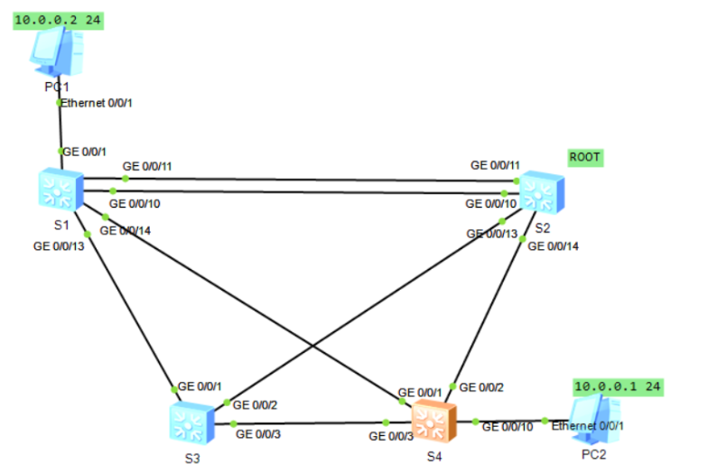
Проверка что произойдет при отключении порта. До отключения (PC2-PC1):
PC>ping 10.0.0.2

Ping 10.0.0.2: 32 data bytes, Press Ctrl_C to break
From 10.0.0.2: bytes=32 seq=1 ttl=128 time=109 ms
From 10.0.0.2: bytes=32 seq=2 ttl=128 time=78 ms
From 10.0.0.2: bytes=32 seq=3 ttl=128 time=78 ms
From 10.0.0.2: bytes=32 seq=4 ttl=128 time=78 ms
From 10.0.0.2: bytes=32 seq=5 ttl=128 time=79 ms
+ stutdown
[S4-GigabitEthernet0/0/2]dis stp brief
MSTID Port Role STP State Protection
0 GigabitEthernet0/0/1 ALTE DISCARDING NONE
0 GigabitEthernet0/0/3 ROOT FORWARDING NONE
0 GigabitEthernet0/0/10 DESI FORWARDING NONE

PC>ping 10.0.0.2

Ping 10.0.0.2: 32 data bytes, Press Ctrl_C to break
From 10.0.0.2: bytes=32 seq=1 ttl=128 time=93 ms
From 10.0.0.2: bytes=32 seq=2 ttl=128 time=94 ms
From 10.0.0.2: bytes=32 seq=3 ttl=128 time=94 ms
From 10.0.0.2: bytes=32 seq=4 ttl=128 time=78 ms
From 10.0.0.2: bytes=32 seq=5 ttl=128 time=94 ms

--- 10.0.0.2 ping statistics ---
5 packet(s) transmitted
5 packet(s) received
0.00% packet loss
round-trip min/avg/max = 78/90/94 ms

Конфигурации
sysname S1
#
stp mode rstp
stp instance 0 root primary
#
interface GigabitEthernet0/0/12
shutdown
#
user-interface con 0
idle-timeout 0 0
#
return
#

sysname S2
#
stp mode rstp
stp instance 0 root secondary
#
interface GigabitEthernet0/0/12
shutdown
#

sysname S3
#
stp mode rstp
#

sysname S4
#
stp mode rstp
#
interface GigabitEthernet0/0/1
stp instance 0 cost 50000
#
interface GigabitEthernet0/0/2
shutdown
#
interface GigabitEthernet0/0/10
stp edged-port enable
#
interface GigabitEthernet0/0/11
stp edged-port enable
#
interface GigabitEthernet0/0/12
stp edged-port enable
#
interface GigabitEthernet0/0/13
stp edged-port enable
#
interface GigabitEthernet0/0/14
stp edged-port enable
#

Лабораторная работа 3. Агрегирование каналов Ethernet

Задачи
- Настройка агрегирования каналов вручную.
- Настройка агрегирования каналов в режиме LACP.
- Изменение параметров для определения активных каналов.
- Изменение режима балансировки нагрузки.

Топология сети
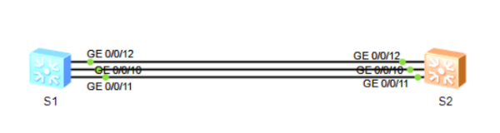

Настраивание и диагностические команды
Шаг 1.
Выполнить ручную настройку Eth-Trunk. Шаги совпадают с методичкой, демонстрация:
[S1-GigabitEthernet0/0/12]dis eth-trunk 1
Eth-Trunk1's state information is:
WorkingMode: NORMAL Hash arithmetic: According to SIP-XOR-DIP
Least Active-linknumber: 1 Max Bandwidth-affected-linknumber: 8
Operate status: up Number Of Up Port In Trunk: 3
--------------------------------------------------------------------------------
PortName Status Weight
GigabitEthernet0/0/10 Up 1
GigabitEthernet0/0/11 Up 1
GigabitEthernet0/0/12 Up 1
[S2-Eth-Trunk1]dis eth-trunk 1
Eth-Trunk1's state information is:
WorkingMode: NORMAL Hash arithmetic: According to SIP-XOR-DIP
Least Active-linknumber: 1 Max Bandwidth-affected-linknumber: 8
Operate status: up Number Of Up Port In Trunk: 3
--------------------------------------------------------------------------------
PortName Status Weight
GigabitEthernet0/0/10 Up 1
GigabitEthernet0/0/11 Up 1
GigabitEthernet0/0/12 Up 1
Шаг 2.
Настроить в режиме LACP:
[S1-Eth-Trunk1]dis eth-trunk 1
Eth-Trunk1's state information is:
Local:
LAG ID: 1 WorkingMode: STATIC
Preempt Delay: Disabled Hash arithmetic: According to SIP-XOR-DIP
System Priority: 32768 System ID: 4c1f-cc19-2f8c
Least Active-linknumber: 1 Max Active-linknumber: 8
Operate status: up Number Of Up Port In Trunk: 3
--------------------------------------------------------------------------------
ActorPortName Status PortType PortPri PortNo PortKey PortState Weight

GigabitEthernet0/0/10 Selected 1GE 32768 11 305 10111100 1
GigabitEthernet0/0/11 Selected 1GE 32768 12 305 10111100 1
GigabitEthernet0/0/12 Selected 1GE 32768 13 305 10111100 1

Partner:
--------------------------------------------------------------------------------
ActorPortName SysPri SystemID PortPri PortNo PortKey PortState
GigabitEthernet0/0/10 32768 4c1f-cc27-2d26 32768 11 305 10111100
GigabitEthernet0/0/11 32768 4c1f-cc27-2d26 32768 12 305 10111100
GigabitEthernet0/0/12 32768 4c1f-cc27-2d26 32768 13 305 10111100
[S2-Eth-Trunk1]dis eth-t 1
Eth-Trunk1's state information is:
Local:
LAG ID: 1 WorkingMode: STATIC
Preempt Delay: Disabled Hash arithmetic: According to SIP-XOR-DIP
System Priority: 32768 System ID: 4c1f-cc27-2d26
Least Active-linknumber: 1 Max Active-linknumber: 8
Operate status: up Number Of Up Port In Trunk: 3
--------------------------------------------------------------------------------
ActorPortName Status PortType PortPri PortNo PortKey PortState Weight
GigabitEthernet0/0/10 Selected 1GE 32768 11 305 10111100 1
GigabitEthernet0/0/11 Selected 1GE 32768 12 305 10111100 1
GigabitEthernet0/0/12 Selected 1GE 32768 13 305 10111100 1

Partner:
--------------------------------------------------------------------------------
ActorPortName SysPri SystemID PortPri PortNo PortKey PortState
GigabitEthernet0/0/10 32768 4c1f-cc19-2f8c 32768 11 305 10111100
GigabitEthernet0/0/11 32768 4c1f-cc19-2f8c 32768 12 305 10111100
GigabitEthernet0/0/12 32768 4c1f-cc19-2f8c 32768 13 305 10111100
Шаг 3.
Настроить LACP, задав System Priority для S1, изменив приоритет порта, установив минимальное и максимальное число портов.
[S1-Eth-Trunk1]
Oct 11 2023 08:18:36-08:00 S1 DS/4/DATASYNC_CFGCHANGE:OID 1.3.6.1.4.1.2011.5.25.
191.3.1 configurations have been changed. The current change number is 16, the c
hange loop count is 0, and the maximum number of records is 4095.
[S1-Eth-Trunk1]dis eth-t
[S1-Eth-Trunk1]dis eth-trunk 1
Eth-Trunk1's state information is:
Local:
LAG ID: 1 WorkingMode: STATIC
Preempt Delay Time: 30 Hash arithmetic: According to SIP-XOR-DIP
System Priority: 100 System ID: 4c1f-cc19-2f8c
Least Active-linknumber: 2 Max Active-linknumber: 2
Operate status: up Number Of Up Port In Trunk: 2
--------------------------------------------------------------------------------
ActorPortName Status PortType PortPri PortNo PortKey PortState Weight
GigabitEthernet0/0/10 Unselect 1GE 40000 11 305 10100000 1
GigabitEthernet0/0/11 Selected 1GE 32768 12 305 10111100 1
GigabitEthernet0/0/12 Selected 1GE 32768 13 305 10111100 1

Partner:
--------------------------------------------------------------------------------
ActorPortName SysPri SystemID PortPri PortNo PortKey PortState
GigabitEthernet0/0/10 32768 4c1f-cc27-2d26 32768 11 305 10110000
GigabitEthernet0/0/11 32768 4c1f-cc27-2d26 32768 12 305 10111100
GigabitEthernet0/0/12 32768 4c1f-cc27-2d26 32768 13 305 10111100
После отключения G0/0/12:
[S1-GigabitEthernet0/0/12]dis eth-trunk 1
Eth-Trunk1's state information is:
Local:
LAG ID: 1 WorkingMode: STATIC
Preempt Delay Time: 30 Hash arithmetic: According to SIP-XOR-DIP
System Priority: 100 System ID: 4c1f-cc19-2f8c
Least Active-linknumber: 2 Max Active-linknumber: 2
Operate status: up Number Of Up Port In Trunk: 2
--------------------------------------------------------------------------------
ActorPortName Status PortType PortPri PortNo PortKey PortState Weight
GigabitEthernet0/0/10 Selected 1GE 40000 11 305 10111100 1
GigabitEthernet0/0/11 Selected 1GE 32768 12 305 10111100 1
GigabitEthernet0/0/12 Unselect 1GE 32768 13 305 10100010 1

Partner:
--------------------------------------------------------------------------------
ActorPortName SysPri SystemID PortPri PortNo PortKey PortState
GigabitEthernet0/0/10 32768 4c1f-cc27-2d26 32768 11 305 10111100
GigabitEthernet0/0/11 32768 4c1f-cc27-2d26 32768 12 305 10111100
GigabitEthernet0/0/12 0 0000-0000-0000 0 0 0 10100011
После отключения G0/0/11 Eth-Trunk отключается, так как кол-во активных портов меньше, чем least:
Eth-Trunk1's state information is:
Local:
LAG ID: 1 WorkingMode: STATIC
Preempt Delay Time: 30 Hash arithmetic: According to SIP-XOR-DIP
System Priority: 100 System ID: 4c1f-cc19-2f8c
Least Active-linknumber: 2 Max Active-linknumber: 2
Operate status: down Number Of Up Port In Trunk: 0
--------------------------------------------------------------------------------
ActorPortName Status PortType PortPri PortNo PortKey PortState Weight
GigabitEthernet0/0/10 Unselect 1GE 40000 11 305 10100000 1
GigabitEthernet0/0/11 Unselect 1GE 32768 12 305 10100010 1
GigabitEthernet0/0/12 Unselect 1GE 32768 13 305 10100010 1

Partner:
--------------------------------------------------------------------------------
ActorPortName SysPri SystemID PortPri PortNo PortKey PortState
GigabitEthernet0/0/10 32768 4c1f-cc27-2d26 32768 11 305 10110000
GigabitEthernet0/0/11 0 0000-0000-0000 0 0 0 10100011
GigabitEthernet0/0/12 0 0000-0000-0000 0 0 0 10100011
Шаг 4.
Изменить режим балансировки нагрузки на с использованием IP. Вернуть интерфейсы во включенное состояние:
[S1-Eth-Trunk1]dis eth-trunk 1
Eth-Trunk1's state information is:
Local:
LAG ID: 1 WorkingMode: STATIC
Preempt Delay Time: 30 Hash arithmetic: According to DIP
System Priority: 100 System ID: 4c1f-cc19-2f8c
Least Active-linknumber: 2 Max Active-linknumber: 2
Operate status: up Number Of Up Port In Trunk: 2
--------------------------------------------------------------------------------
ActorPortName Status PortType PortPri PortNo PortKey PortState Weight
GigabitEthernet0/0/10 Unselect 1GE 40000 11 305 10100000 1
GigabitEthernet0/0/11 Selected 1GE 32768 12 305 10111100 1
GigabitEthernet0/0/12 Selected 1GE 32768 13 305 10111100 1

Partner:
--------------------------------------------------------------------------------
ActorPortName SysPri SystemID PortPri PortNo PortKey PortState
GigabitEthernet0/0/10 32768 4c1f-cc27-2d26 32768 11 305 10110000
GigabitEthernet0/0/11 32768 4c1f-cc27-2d26 32768 12 305 10111100
GigabitEthernet0/0/12 32768 4c1f-cc27-2d26 32768 13 305 10111100

Конфигурации
#
sysname S1
#
lacp priority 100
#
interface Eth-Trunk1
mode lacp-static
least active-linknumber 2
load-balance dst-ip
lacp preempt enable
max active-linknumber 2
#
interface GigabitEthernet0/0/10
eth-trunk 1
lacp priority 40000
#
interface GigabitEthernet0/0/11
eth-trunk 1
#
interface GigabitEthernet0/0/12
eth-trunk 1
#
user-interface con 0
idle-timeout 0 0
#
return
#
sysname S2
#
interface Eth-Trunk1
mode lacp-static
#
interface GigabitEthernet0/0/10
eth-trunk 1
#
interface GigabitEthernet0/0/11
eth-trunk 1
#
interface GigabitEthernet0/0/12
eth-trunk 1
#
user-interface con 0
idle-timeout 0 0
#
return

Лабораторная работа 4. Связь между VLAN

Задачи
- Настройка подинтерфейсов терминирования dot1q для реализации связи между VLAN.
- Настройка интерфейсов VLANIF для реализации связи между VLAN.

Топология сети
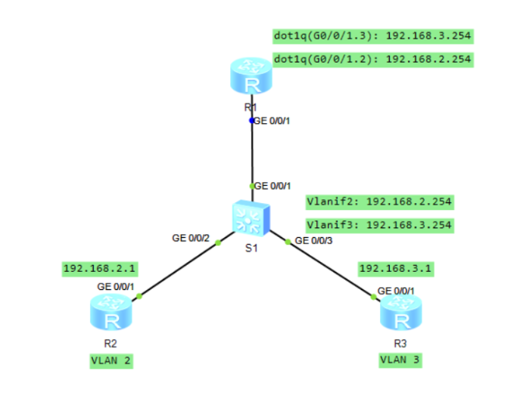

Настраивание и диагностические команды
Шаг 1.
Настроить основные параметры устройств:
sysname R2
ip route-static 0.0.0.0 0.0.0.0 192.168.2.254

sysname R3
ip route-static 0.0.0.0 0.0.0.0 192.168.3.254

S1
VID Status Property MAC-LRN Statistics Description
--------------------------------------------------------------------------------

1 enable default enable disable VLAN 0001
2 enable default enable disable VLAN 0002
3 enable default enable disable VLAN 0003
interface GigabitEthernet0/0/2
port link-type access
port default vlan 2
#
interface GigabitEthernet0/0/3
port link-type access
port default vlan 3
Шаг 2.
Настроить подинтерфейсы терминирования dot1q для реализации связи между VLAN:
[S1-GigabitEthernet0/0/1]dis this
#
interface GigabitEthernet0/0/1
port link-type trunk
port trunk allow-pass vlan 2 to 3
#
return

[R1]dis dot1q information termination interface g0/0/1
GigabitEthernet0/0/1.2
Total QinQ Num: 1
dot1q termination vid 2
Total vlan-group Num: 0
GigabitEthernet0/0/1.3
Total QinQ Num: 1
dot1q termination vid 3
Total vlan-group Num: 0
Таким образом, при приеме например кадра с vlan 2, в данной конфигурации он отправляется на подинтерфейс 2 через g0/0/1, а затем, так как dest ip 192.168.3.1, дальнейшая обработка идет к подинтерфейсу 3 по таблице маршрутизации. После этого, кадр с уже тегом 3 отправляется на коммутатор.
[R2]ping 192.168.3.1
PING 192.168.3.1: 56 data bytes, press CTRL_C to break
Reply from 192.168.3.1: bytes=56 Sequence=1 ttl=254 time=90 ms
Reply from 192.168.3.1: bytes=56 Sequence=2 ttl=254 time=130 ms
Reply from 192.168.3.1: bytes=56 Sequence=3 ttl=254 time=100 ms
Reply from 192.168.3.1: bytes=56 Sequence=4 ttl=254 time=100 ms
Reply from 192.168.3.1: bytes=56 Sequence=5 ttl=254 time=80 ms
Шаг 3.
Настроить интерфейсы VLANIF, удалив предыдущую конфигурацию.
[R2]ping 192.168.3.1
PING 192.168.3.1: 56 data bytes, press CTRL_C to break
Reply from 192.168.3.1: bytes=56 Sequence=1 ttl=254 time=160 ms
Reply from 192.168.3.1: bytes=56 Sequence=2 ttl=254 time=70 ms
Reply from 192.168.3.1: bytes=56 Sequence=3 ttl=254 time=50 ms
Reply from 192.168.3.1: bytes=56 Sequence=4 ttl=254 time=50 ms
Reply from 192.168.3.1: bytes=56 Sequence=5 ttl=254 time=60 ms

--- 192.168.3.1 ping statistics ---
5 packet(s) transmitted
5 packet(s) received
0.00% packet loss
round-trip min/avg/max = 50/78/160 ms

[R2]tracert 192.168.3.1

traceroute to 192.168.3.1(192.168.3.1), max hops: 30 ,packet length: 40,press
CTRL_C to break

1 192.168.2.254 20 ms 70 ms 10 ms

2 192.168.3.1 50 ms 70 ms 40 ms

Конфигурации
sysname R2
#
interface GigabitEthernet0/0/0
#
interface GigabitEthernet0/0/1
ip address 192.168.2.1 255.255.255.0
#
interface GigabitEthernet0/0/2
#
interface NULL0
#
ip route-static 0.0.0.0 0.0.0.0 192.168.2.254
#

sysname R3
#
interface GigabitEthernet0/0/0
#
interface GigabitEthernet0/0/1
ip address 192.168.3.1 255.255.255.0
#
interface GigabitEthernet0/0/2
#
interface NULL0
#
ip route-static 0.0.0.0 0.0.0.0 192.168.3.254
#

sysname S1
#
interface Vlanif1
#
interface Vlanif2
ip address 192.168.2.254 255.255.255.0
#
interface Vlanif3
ip address 192.168.3.254 255.255.255.0
#
interface MEth0/0/1
#
interface GigabitEthernet0/0/1
#
interface GigabitEthernet0/0/2
port link-type access
port default vlan 2
#
interface GigabitEthernet0/0/3
port link-type access
port default vlan 3
#

Усложненная топология. Объединение региона SMTP и STP, добавление VLAN

Топология сети
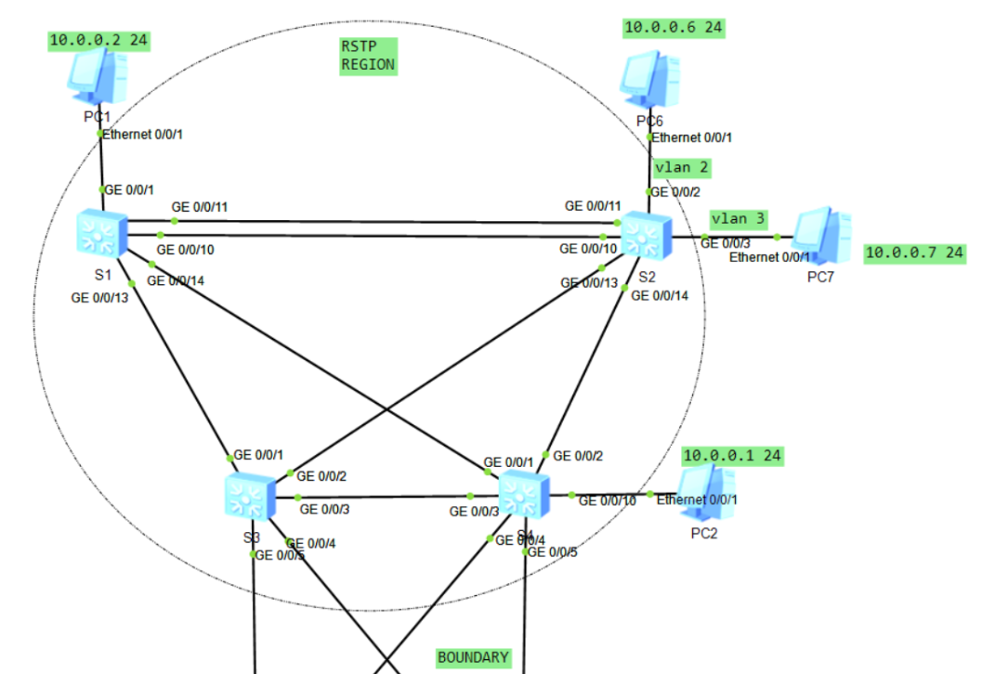
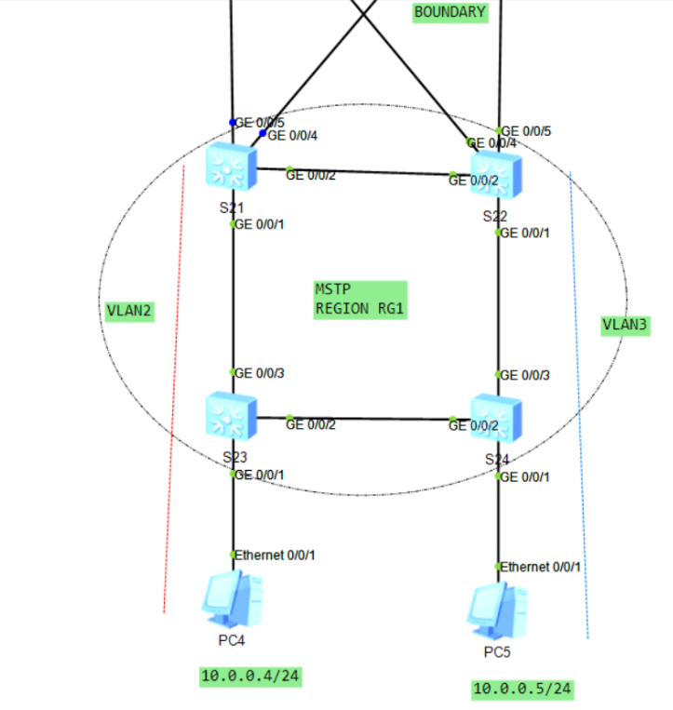

Конфигурации
#
sysname S21
#
vlan batch 2 to 3
#
stp pathcost-standard legacy
#
stp instance 1 root primary
stp instance 2 root secondary
stp pathcost-standard legacy
#
stp region-configuration
region-name RG1
instance 1 vlan 2
instance 2 vlan 3
active region-configuration
#
drop-profile default
#
interface Vlanif1
#
interface MEth0/0/1
#
interface GigabitEthernet0/0/1
port link-type trunk
port trunk allow-pass vlan 2 to 3
#
interface GigabitEthernet0/0/2
port link-type trunk
port trunk allow-pass vlan 2 to 3
#
interface GigabitEthernet0/0/3
#
interface GigabitEthernet0/0/4
port link-type trunk
port trunk allow-pass vlan 2 to 3
#
interface GigabitEthernet0/0/5
port link-type trunk
port trunk allow-pass vlan 2 to 3
#

#
sysname S22
#
vlan batch 2 to 3
#
stp pathcost-standard legacy
#
stp instance 1 root secondary
stp instance 2 root primary
stp pathcost-standard legacy
#
stp region-configuration
region-name RG1
instance 1 vlan 2
instance 2 vlan 3
active region-configuration
#
interface GigabitEthernet0/0/1
port link-type trunk
port trunk allow-pass vlan 2 to 3
#
interface GigabitEthernet0/0/2
port link-type trunk
port trunk allow-pass vlan 2 to 3
#
interface GigabitEthernet0/0/3
#
interface GigabitEthernet0/0/4
port link-type trunk
port trunk allow-pass vlan 2 to 3
#
interface GigabitEthernet0/0/5
port link-type trunk
port trunk allow-pass vlan 2 to 3
#

#
sysname S23
#
vlan batch 2 to 3
#
stp pathcost-standard legacy
#
stp region-configuration
region-name RG1
instance 1 vlan 2
instance 2 vlan 3
active region-configuration
#
interface GigabitEthernet0/0/1
port link-type access
port default vlan 2
stp edged-port enable
#
interface GigabitEthernet0/0/2
port link-type trunk
port trunk allow-pass vlan 2 to 3
stp instance 2 cost 200
#
interface GigabitEthernet0/0/3
port link-type trunk
port trunk allow-pass vlan 2 to 3
#

#
sysname S24
#
vlan batch 2 to 3
#
stp pathcost-standard legacy
#
stp region-configuration
region-name RG1
instance 1 vlan 2
instance 2 vlan 3
active region-configuration
#
interface GigabitEthernet0/0/1
port link-type access
port default vlan 3
stp edged-port enable
#
interface GigabitEthernet0/0/2
port link-type trunk
port trunk allow-pass vlan 2 to 3
stp instance 1 cost 200
#
interface GigabitEthernet0/0/3
port link-type trunk
port trunk allow-pass vlan 2 to 3
#

#
sysname S1
#
vlan batch 2 to 3
#
stp mode rstp
stp instance 0 root primary
#
interface GigabitEthernet0/0/10
port hybrid tagged vlan 2 to 3
#
interface GigabitEthernet0/0/11
port hybrid tagged vlan 2 to 3
#
interface GigabitEthernet0/0/12
shutdown
#
interface GigabitEthernet0/0/13
port hybrid tagged vlan 2 to 3
#
interface GigabitEthernet0/0/14
port hybrid tagged vlan 2 to 3
#

#
sysname S2
#
vlan batch 2 to 3
#
stp mode rstp
stp instance 0 root secondary
#
interface GigabitEthernet0/0/2
port link-type access
port default vlan 2
#
interface GigabitEthernet0/0/3
port link-type access
port default vlan 3
#
interface GigabitEthernet0/0/10
port hybrid tagged vlan 2 to 3
#
interface GigabitEthernet0/0/11
port hybrid tagged vlan 2 to 3
#
interface GigabitEthernet0/0/12
shutdown
#
interface GigabitEthernet0/0/13
port hybrid tagged vlan 2 to 3
#
interface GigabitEthernet0/0/14
port hybrid tagged vlan 2 to 3
#

#
sysname S3
#
vlan batch 2 to 3
#
stp mode rstp
#
interface GigabitEthernet0/0/1
port hybrid tagged vlan 2 to 3
#
interface GigabitEthernet0/0/2
port hybrid tagged vlan 2 to 3
#
interface GigabitEthernet0/0/3
port hybrid tagged vlan 2 to 3
#
interface GigabitEthernet0/0/4
port hybrid tagged vlan 2 to 3
#
interface GigabitEthernet0/0/5
port hybrid tagged vlan 2 to 3
#

#
sysname S4
#
vlan batch 2 to 3
#
stp mode rstp
#
interface GigabitEthernet0/0/1
port hybrid tagged vlan 2 to 3
stp instance 0 cost 50000
#
interface GigabitEthernet0/0/2
port hybrid tagged vlan 2 to 3
#
interface GigabitEthernet0/0/3
port hybrid tagged vlan 2 to 3
#
interface GigabitEthernet0/0/4
port hybrid tagged vlan 2 to 3
#
interface GigabitEthernet0/0/5
port hybrid tagged vlan 2 to 3
#
interface GigabitEthernet0/0/10
stp edged-port enable
#
interface GigabitEthernet0/0/11
stp edged-port enable
#
interface GigabitEthernet0/0/12
stp edged-port enable
#
interface GigabitEthernet0/0/13
stp edged-port enable
#
interface GigabitEthernet0/0/14
stp edged-port enable
#

